

**Semester Two**

**Examination 2016**

**Question/Answer booklet**

**MATHEMATICS**

**SPECIALIST UNITS 3 & 4**

**Section Two:**

**Calculator-assumed**

|  |
| --- |
| Student Name: _____________________________________ |
| Teacher’s Name: _____________________________________ |

**Time allowed for this section**

Reading time before commencing work: ten minutes

Working time for paper: one hundred minutes

**Material required/recommended for this section**

**To be provided by the supervisor**

This Question/Answer booklet

Formula Sheet (retained from Section One)

**To be provided by the candidate**

Standard items: pens (blue/black preferred), pencils (including coloured), sharpener, correction tape/fluid, erasers, ruler, highlighters

Special Items: drawing instruments, templates, notes on two unfolded sheets of A4 paper, and up to three calculators approved for use in the WACE examinations.

**Important note to candidates**

No other items may be taken into the examination room. It is **your** responsibility to ensure that you do not have any unauthorised notes or other items of a non-personal nature in the examination room. If you have any unauthorised material with you, hand it to the supervisor **before** reading any further.

**Structure of this paper**

|  |  |  |  |  |  |
| --- | --- | --- | --- | --- | --- |
|  | Number of questions available | Number of questions to be attempted | Working time (minutes) | Marks available | Percentage of exam |
| **Section One**  **Calculator—free** | **6** | **6** | **50** | **50** | **35** |
| Section Two  Calculator—assumed | 12 | 12 | 100 | 100 | 65 |
|  | | | |  | 100 |

**Instructions to candidates**

1. The rules for the conduct of Western Australian external examinations are detailed in the

*Year 12 Information Handbook 2016.* Sitting this examination implies that you agree to abide by these rules.

1. Answer the questions according to the following instructions.

**Show all your working clearly.** Your working should be in sufficient detail to allow your

answers to be checked readily and for marks to be awarded for reasoning. Incorrect answers given without supporting reasoning cannot be allocated any marks. For any question or part question worth more than two marks, valid working or justification is required to receive full marks. If you repeat an answer to any question, ensure that you cancel the answer you do not wish to have marked.

It is recommended that you **do not use pencil**, except in diagrams.

1. You must be careful to confine your responses to the specific questions asked and to follow any instructions that are specific to a particular question.
2. Spare pages are included at the end of this booklet. They can be used for planning your responses and/or as additional space if required to continue an answer.

* Planning: If you use the spare pages for planning, indicate this clearly at the top of the page.
* Continuing an answer: If you need to use the space to continue an answer, indicate in the original answer space where the answer is continued, i.e. give the page number. Fill in the number of the question that you are continuing to answer at the top of the page.

1. The Formula Sheet is **not** handed in with your Question/Answer Booklet.

# Section Two: Calculator–assumed 65% (100 marks)

This section has **twelve (12)** questions. Attempt **all** questions. Write your answers in the spaces

provided.

Working time: 100 minutes

**Question 7 (5 marks)**

The polynomial $Q\left(z\right)=z^{4}+az^{3}+bz^{2}+cz+d$ has real coefficients, and two of its roots are $z=1+2i$ and $z=3i$.

(a) State the other two roots of $Q(z)$. (2 marks)

(b) Write $Q(z)$ in its fully factorised format. (1 mark)

(c) State the value of the coefficients $a, b, c$ and $d$. (2 marks)

**Question 8 (15 marks)**

Let f $\left(x\right)=5+\sqrt{x}$, $x≥0$, and $g\left(x\right)={\left(x-5\right)}^{2}$, $x∈R$.

(a) Determine $f\left(g\left(x\right)\right)$ and $g∘f(x)$ and state the domain and range for each. (6 marks)

(b) Determine the value(s) of $a$ for which $f\left(g\left(a\right)\right)=g∘f(a)$. (2 marks)

**Question 8 (Continued)**

(c) The function $h(x)$ is such that $g\left(h\left(x\right)\right)=x^{2}+6x+9$. Determine $h(x)$. (2 marks)

(d) Sketch $f\left(\left|x\right|\right)$ for $x∈R$ and $\frac{1}{g(x)}$ on the grid below, clearly labelling all features. (5 marks)

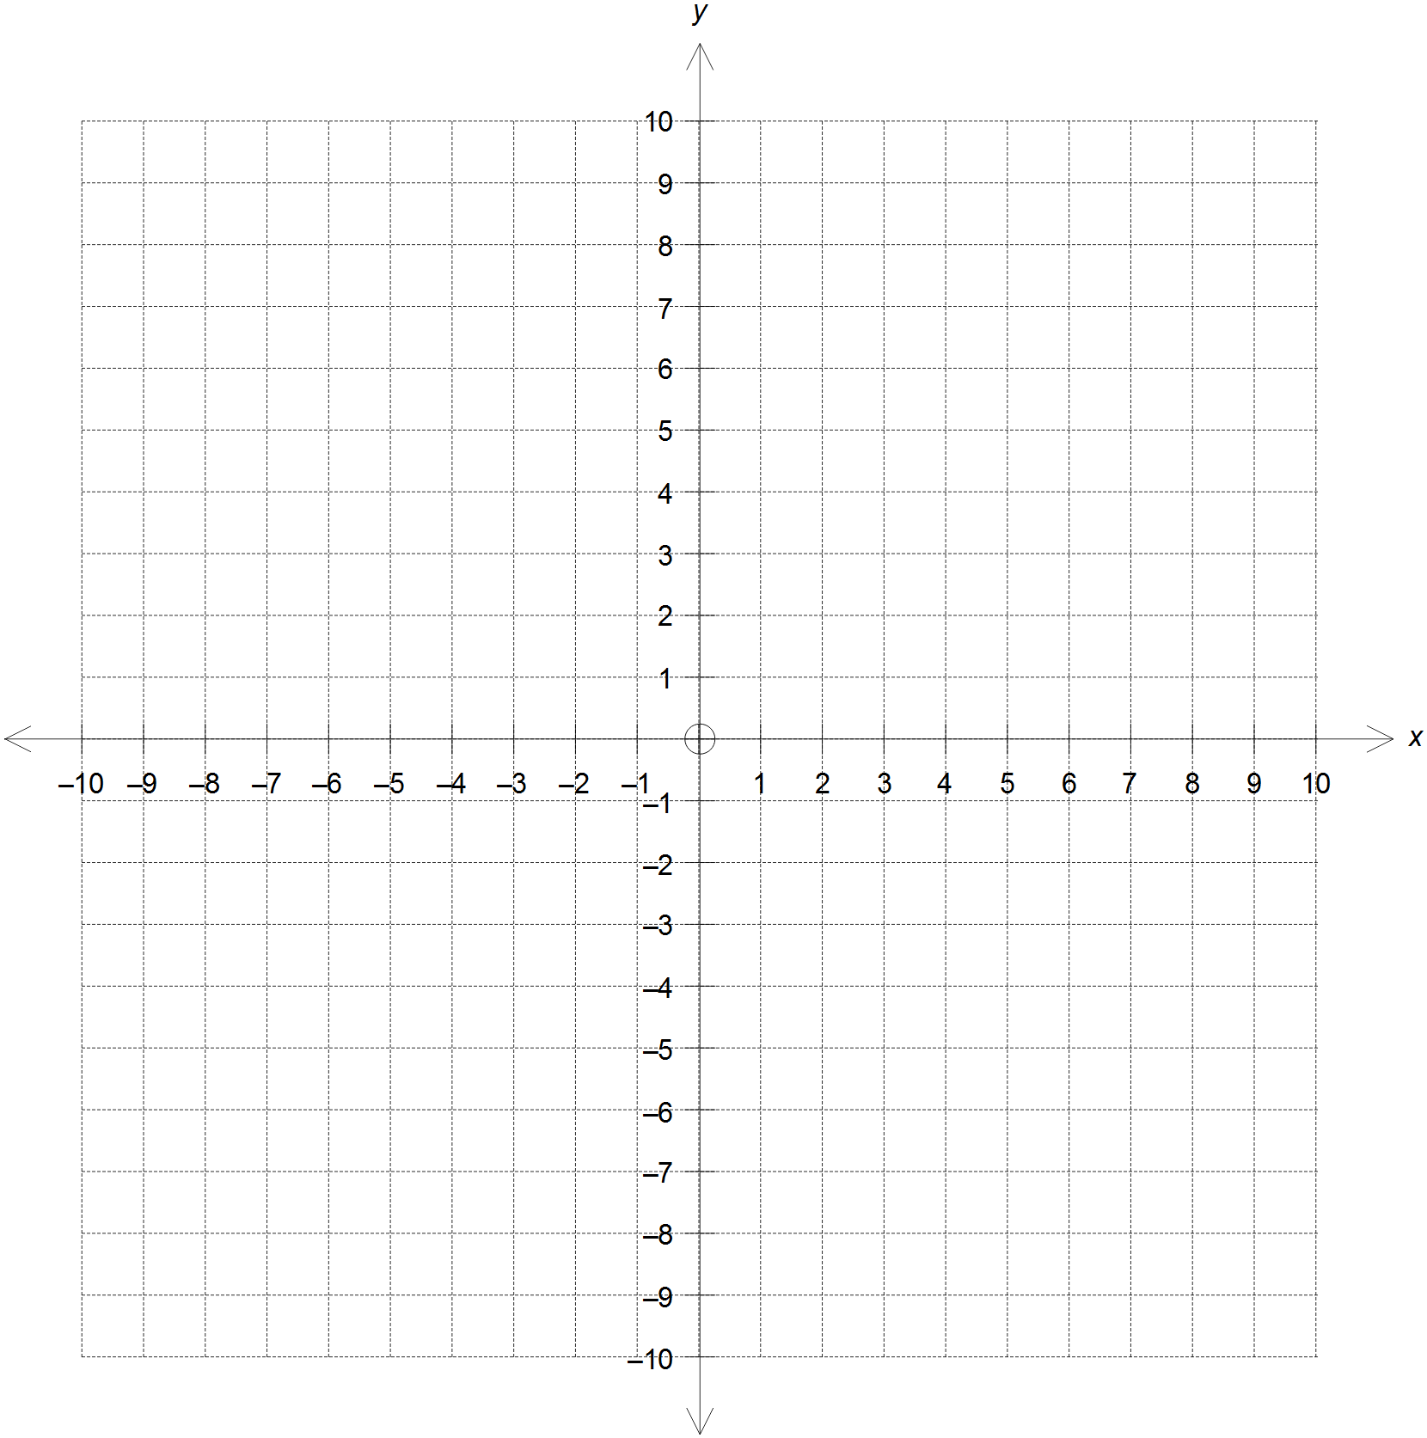

**Question 9 (8 marks)**

In an effort to control the breeding of mosquitoes in an artificial pond, the local council introduced coy fish to eat the larvae on the surface of the water. This particular population of fish increases at a rate that is proportional to the existing population, which is represented by the rule:

$$\frac{dP}{dt}=kP$$

where $P$ is the total population of fish as a function of time, $t$ is the time in years since their introduction into the pond, and $k$ is a constant.

(a) Use calculus to determine the population of fish $P(t)$ in terms of $t$ and $k$. (3 marks)

(b) If the population of fish is increasing at a rate of 24% per year and the population released

initially was 2 500 fish, determine:

(i) the expected population of fish 30 months after their introduction. (3 marks)

(ii) how many years it would be expected for the population of fish to reach the

maximum capacity of 20 000 fish. (2 marks)

**Question 10 (7 marks)**

A particle moves along the *x*-axis so that its displacement $x$, in metres, from the origin at any

time $t$, in seconds, is given by:

$$x=5+2\cos{(4t)}$$

(a) Show that the particle executes simple harmonic motion about some point $P$ on the *x*-axis by establishing a relation between its acceleration and its displacement from $P$.

(3 marks)

(b) Find the point(s) on its path of motion where its speed is $4 ms^{-1}$. (3 marks)

(c) Determine the acceleration of the particle when it is located $1 m$ to the left of $P$ (1 mark)

**Question 11 (10 marks)**

The complex number $2\sqrt{3}-2i$ is a cube root of the complex number $z$.

(a) Find the other two cube roots in:

(i) polar form. (3 marks)

(ii) Cartesian form. (2 marks)

**Question 11 (Continued)**

(b) Plot the roots found in (a) on the grid below. (2 marks)

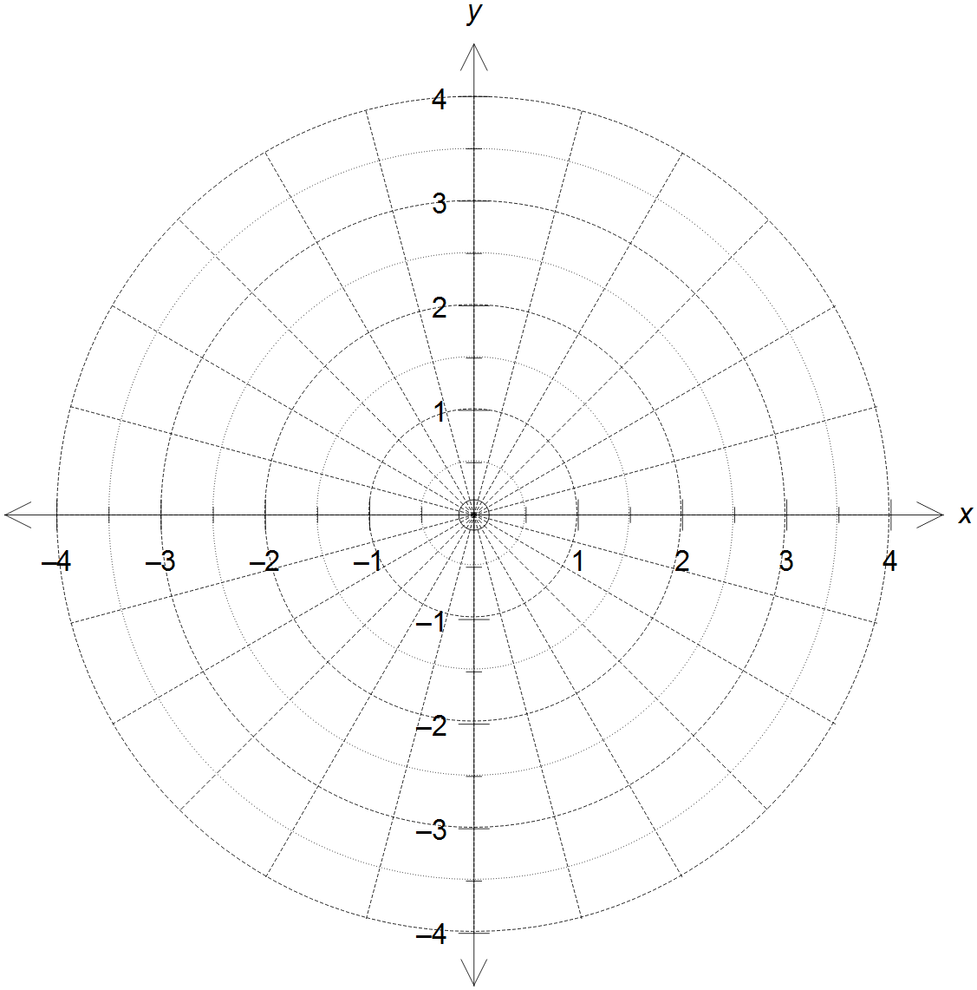

(c) The roots form the vertices of a triangle. Determine the exact perimeter of this triangle. (3 marks)

**Question 12 (8 marks)**

The manufacturer of a popular CAS calculator claims that the standard deviation of the battery life of their device is 12 hours. A group of students plan to estimate $μ$, the mean battery life of these CAS calculators, using the mean battery life of a random sample of these calculators taken from students in their school.

(a) The students would like to be 95% confident that the mean battery life of these calculators

in the sample is within 4 hours of $μ$. How large should the sample size be?

(3 marks)

(b) The students were able to collect a sample of 60 calculators, and the mean battery life of

these calculators was 94 hours. Based on this sample, determine a 90% confidence

interval for $μ$.

(3 marks)

(c) The manufacturer claims that the mean battery life of these CAS calculators is 100 hours.

Does the sample in (b) support this claim? Explain.

(2 marks)

**Question 13 (6 marks)**

(a) Sketch the graph of $y=\left|x+2\right|-\left|x-2\right|$ on the grid provided below. (2 marks)

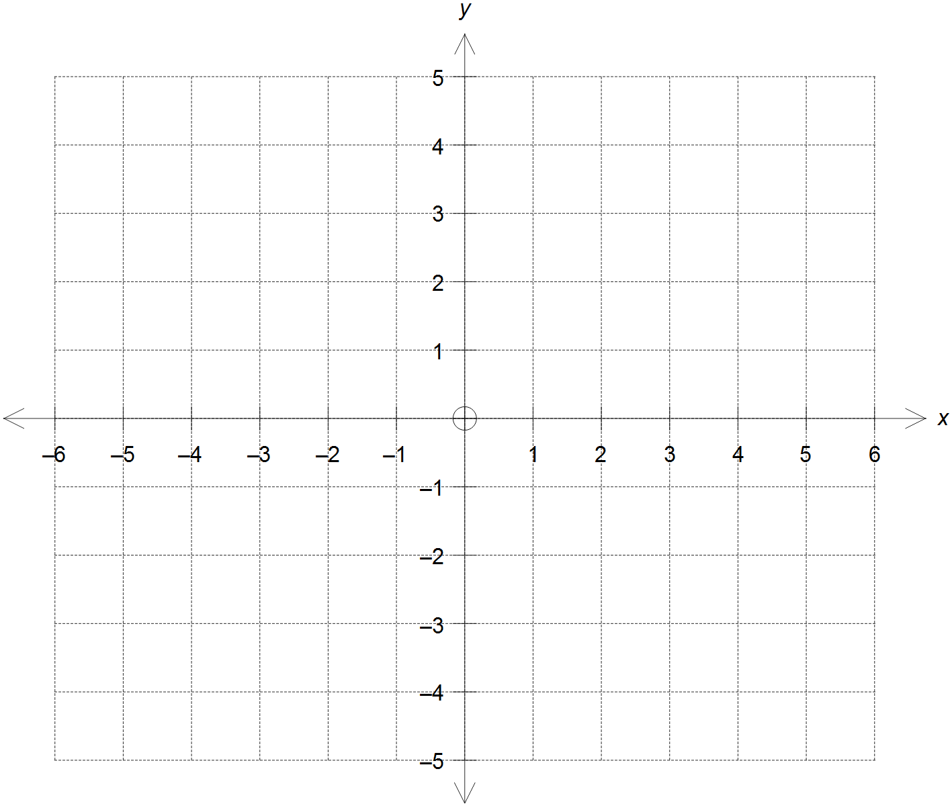

(b) Use your graph to determine the value(s) of the real constants $a, b$ and $c$ if the equation:

$$\left|x+2\right|-\left|x-2\right|=a\left|x+b\right|+c$$

is satisfied $∀ x∈\left[-2, 2\right]$ but no other real values. (4 marks)

**Question 14 (14 marks)**

The plane  has equation $r=\left(\begin{matrix}1 \\ 0 \\ 1\end{matrix}\right)+λ\left(\begin{matrix}1 \\ 2 \\ 0\end{matrix}\right)+μ\left(\begin{matrix}0 \\ 3 \\ 1\end{matrix}\right)$.

(a) Use the cross product to determine a vector normal to the plane  and hence state

the equation of the line L that is perpendicular to the plane  and passes through

the point P $\left(4, -2, 3\right)$. (2 marks)

(b) Determine the point of intersection between the plane  and the line L from (a). (3 marks)

(c) Hence, or otherwise, determine the distance of the point P $\left(4, -2, 3\right)$ from the plane .

(2 marks)

**Question 14 (Continued)**

(d) Determine the acute angle between the plane  and the xy plane. (3 marks)

(e) Determine the vector equation of the sphere centred at the origin that is tangential to

the plane . State the point of tangency. (4 marks)

**Question 15(7 marks)**

Blood flow in the arteries is defined as the volume $V$ of blood flowing per unit of time. This can be modelled by the formula:

$$V=kr^{4}$$

where $r$ is the radius of the artery and $k=15 mm^{-1}$.

(a) Use the incremental formula to estimate the percentage increase required in the radius

of a partially clogged artery to produce a 10% increase in the blood flow. (3 marks)

(b) A particular artery has an initial radius of 2.2 mm and it gets smaller along a limb, where

its radius decreases at a rate of 0.05 mm/cm. Determine the rate at which the blood flow is changing 12 cm into the artery.

(4 marks)

**Question 16 (7 marks)**

In March 2013 the entire fleet of Boeing’s Dreamliner aircraft was grounded due to the overheating

and subsequent fire of the lithium-ion batteries in the plane’s avionics. Looking for a solution, engineers wished to estimate, with a 95% confidence interval, the mean operational temperature of the lithium-ion batteries under normal operating conditions. They believed that the values were normally distributed, and according to a previous study, the population standard deviation was 8°C.

(a) A random sample of 32 of batteries yielded a mean operating temperature of 42.5°C.

Determine the 95% confidence interval for the mean operational temperature of the population

and comment on your findings.

(4 marks)

(b) Engineers decided to narrow the estimate of the mean operating temperature to within

0.5°C of the true mean with 99% confidence. Determine the sample size needed to

achieve such result. (3 marks)

**Question 17 (8 marks)**

A particle moves in the Cartesian plane and the position vector of the particle at any time $t$ in seconds is given by the equation:

$r\left(t\right)=\left(\cos{t}-\frac{1}{2}\right)i+\left(2-\sin{t}\right)j$ for $0≤t≤2π$

(a) Determine the speed of the particle when it first crosses the y-axis. (4 marks)

(b) Show that the particle moves with a constant magnitude of acceleration. (2 marks)

(c) Determine the Cartesian equation of the path traced by the particle and describe

its properties. (2 marks)

**Question 18 (5 marks)**

A first order differential equation has a direction field as shown on the diagram below.

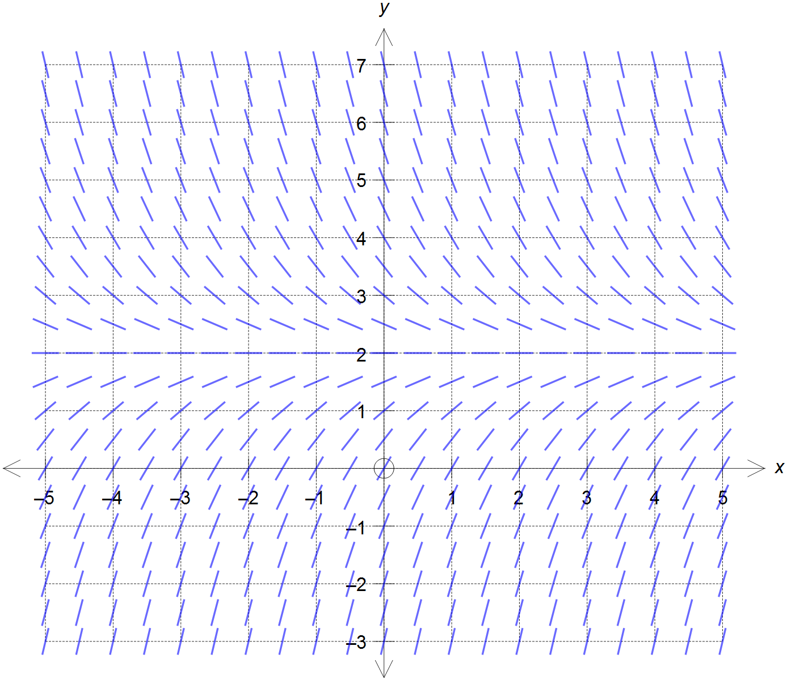

(a) Use the scale shown to determine a general differential equation that would result in

this slope field, giving reasons for your answer. (3 marks)

(b) If the initial conditions are $y=1$ for $x=0$ then sketch on the grid above the graph

of the possible solution to the differential equation. (2 marks)

**End of questions**

**Additional working space**

Question number(s): ……………………

**Additional working space**

Question number(s): ……………………

**Additional working space**

Question number(s): ……………………